AAE5302 U-Space Design, Air Traffic Service and Urban Aircraft System Traffic Management

Individual Report

Name | YAN Yixuan
Student ID | 25107505G
Date: | 2026.4.20

1. Design Background and Core Logic
Hong Kong is a high-density urban metropolis with high-rise canyons, complex airspace environments, and strict aviation safety requirements imposed by Hong Kong International Airport (HKIA). In accordance with the 2024 Policy Address, the HKSAR Government established an inter-departmental Working Group to promote the Low-altitude Economy (LAE) and launched the LAE Regulatory Sandbox to conduct safe and controlled UAS trials. As of October 2025, 28 pilot projects covering logistics delivery, infrastructure inspection, emergency rescue, monitoring, and system development have been implemented, forming stable and predictable UAS operational demand.
Hong Kong has built a complete regulatory system for unmanned aircraft systems (UAS), including the Small Unmanned Aircraft Order (Cap. 448G), Air Navigation (Hong Kong) Order 1995 (Cap. 448C), and CAD Advisory Circular AC-013. A risk-based classification regime is adopted to categorize UAS into A1, A2, B, and C categories with differentiated constraints on registration, operating height, speed, separation distance, and insurance. Restricted Flying Zones (RFZs) are strictly implemented around HKIA, government buildings, and critical infrastructure to ensure aviation and public security.
All design schemes comply with Hong Kong’s legal requirements and ICAO UAS integration principles, aiming to propose a safe, compliant, scalable, and efficient airspace and UTM solution to support large-scale UAS operations in Hong Kong.

2. Airspace Design for Large-Scale UAS Operations in Hong Kong
To support safe, orderly, and large-scale UAV operations in Hong Kong, the airspace design must follow strict regulatory, safety, and operational principles:
- Compliance with Hong Kong’s risk-based regulatory regime
All airspace boundaries, height limits, and operating zones must align with Cap. 448G, Cap. 448C, and AC-013, including restricted flying zones and height restrictions near HKIA.
- Safe segregation between UAS and manned aviation
Given the proximity to HKIA and high air traffic density, the airspace structure must ensure clear separation to avoid interference with commercial aircraft and helicopters.
- Adaptation to Hong Kong’s high-rise urban canyon environment
The design must account for signal blockage, limited maneuvering space, and dense population, ensuring safety and operational reliability in urban areas.
- Matching real demand from the LAE Regulatory Sandbox
The airspace layout must support the actual operational scenarios and sortie volume derived from the 28 ongoing sandbox projects.
- Scalability for future large-scale UTM operations
The structure must support centralized management, dedicated corridors, vertiport integration, and dynamic conflict avoidance for future mass UAV deployment.

3. Operating environment design for HK.

3.1 Vertical and Horizontal Airspace Environment
A three-layer vertical stratification is established (Figure 2) to separate traffic by mission type and risk level.
- Layer 1 (0–200 ft AGL): Designed for low-risk daily operations, including logistics delivery, infrastructure inspection, and R&D activities, accounting for about 70% of total traffic.
- Layer 2 (200–350 ft AGL): Reserved for high-priority missions such as eVTOL passenger transport and emergency services, accounting for about 25% of total traffic.
- Layer 3 (350–400 ft AGL): A dedicated safety buffer layer for contingency and holding purposes; no routine flights are permitted.
Horizontally, two dedicated corridors and two vertiport hubs are deployed (Figure 3).
- The Logistics Corridor (0–200 ft, 8 km) supports daily low-risk flights.
- The Victoria Harbor Corridor (200–350 ft) serves high-priority operations. Kai Tak and West Kowloon are set as core vertiport hubs. Strict no-fly zones are enforced for Hong Kong International Airport (HKIA), government buildings, and critical infrastructure to avoid unauthorized flights.
Figure 1 Vertical Airspace Design
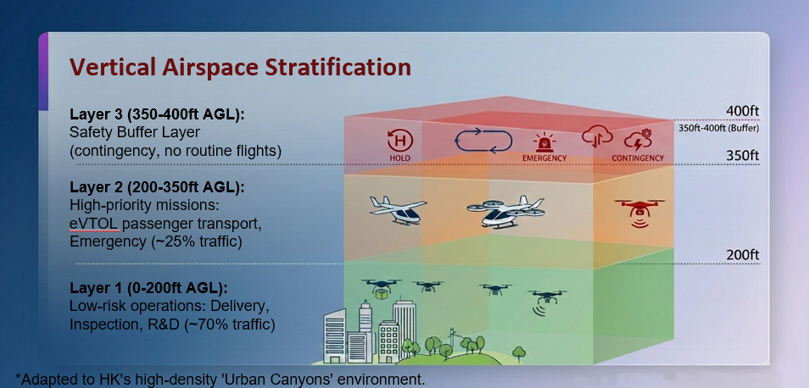
Figure 2 Horizontal Airspace Design
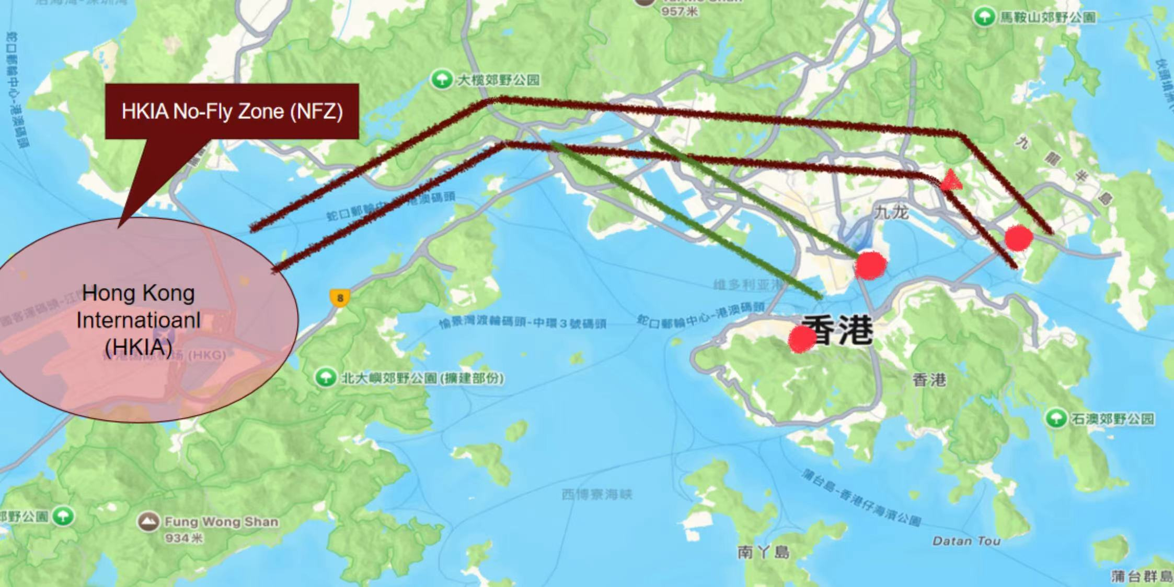

3.2 Regulatory and Technical Infrastructure Environment
The operating environment also fully complies with Hong Kong’s UAS regulatory system, including the Small Unmanned Aircraft Order (Cap. 448G) and Advisory Circular AC-013.
For technical support, the system integrates Remote Identification (RID) and real-time weather monitoring facilities. Remote ID provides continuous identification and positioning broadcasting, supporting traceability and supervision. Weather monitoring equipment collects real-time meteorological data to support operational decisions under typhoon, heavy rain, and other severe conditions.

3.3 Urban Environmental Adaptation and Contingency Protocols
The design addresses typical urban challenges in Hong Kong, especially GNSS signal blockage, multipath errors, and communication instability caused by dense high-rise canyons. Resilient operation mechanisms are embedded to maintain service continuity under signal interference.
A complete contingency protocol is established for extreme weather. The system automatically adjusts or suspends operations based on real-time weather conditions, ensuring operational safety under Hong Kong’s coastal climate characteristics. The operating environment unifies regulatory compliance, technical support, urban adaptability, and emergency response, forming a closed-loop support system for large-scale UTM operations in Hong Kong.

4. Airspace Demand and Capacity Estimation
This section estimates the demand and capacity of the proposed airspace in Hong Kong based on peak-hour operational data and airway design. The analysis verifies whether the stratified airspace and dedicated routes can accommodate the projected peak demand of 188 to 378 sorties, thereby ensuring strategic separation and efficient traffic management. By calculating route utilization and vertiport efficiency, this study confirms that the designed airspace system is capable of supporting safe, stable and scalable operations.

4.1 Demand Estimation
4.1.1 Daily Demand Classification
Airspace demand is defined as the number and distribution of UAS seeking to use a specific airspace block. Two core metrics are adopted:
①Aricraft entry rate : Describe hourly corridor traffic flow
②Occupancy count: Estimate concurrent UAS in peak hours
Daily demand is calculated by the formula:
D_{i}^{min} = N_{i} × a_{i}^{min}
D_{i}^{max} = N_{i} × a_{i}^{max}
Ni is the number of projects of type i
ai is the assumed sortie interval per project per day.
Five mission categories are classified as Table1:
Table 1 Daily UAS Sortie Demand by Mission Type
Mission Type | Project ID | Number | Reasonable sortie assumption | assumption basis | Subtotal  (sorties/day)
UAS Delivery Services | 1, 12, 13, 18, 19 | 5 | 30–60 sorties per route per day | sandbox operating intensity | 150–300
Infrastructure Inspection & Monitoring | 2, 3, 4, 5, 7, 8, 14, 16, 20, 26, 27, 28 | 12 | 10–20 sorties per site per day | government operational standard | 120–240
Emergency & Rescue Services | 11, 25 | 2 | 5–10 sorties per day | on-demand standby mode | 10–20
Drone Show, Aerial Filming & Live Streaming | 9, 15, 21, 23 | 4 | 2–5 sorties per day | non-daily operations | 8–20
System Development, R&D & Others | 6, 10, 17, 22, 24 | 5 | 5–10 sorties per day | testing & research | 25–50
Total | / | 28 | / | / | 313–630
The total daily demand ranges from 313 to 630 sorties. UAS delivery and infrastructure inspection together account for over 80% of total demand, representing the most mature LAE scenarios.
Figure 3 Demand Structure Pie Chart

4.1.2 Peak Demand Forecast
Peak hours are defined as 7:00–10:00 and 17:00–20:00 (6 hours in total), during which 60% of daily traffic concentrates.
Peak daily demands:
$$Dpeak= α × Dtotal =188- 378 sorties$$
where α=0.6
Average peak hourly flow:
$$qpeak = Dpeak / 6 =31-53 sorties/ hour$$
Figure 4 Hourly Distribution of UAS Demand
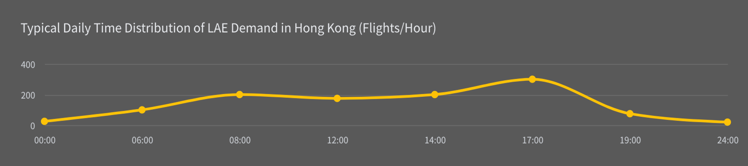
4.1.3 Peak Demand Allocation
The percentage allocation is determined based on the operational structure of Hong Kong's LAE sandbox and airspace stratification logic. Capacity is calculated using two models: waypoint-based capacity model for corridors and vertiport-based capacity model for landing hubs:
- For the two corridors:
Dominant Business Volume (70%): According to the Table 1, UAS delivery and infrastructure inspection accounting for 17 projects, are assigned to the lower altitude layer (0-200 ft) to form the main traffic flow. To test the system’s limits, the corridor has been set to handle 70% of the total peak traffic volume during peak hours.
Priority and Capacity Control (25%): High-priority services such as air-taxi and emergency rescue are allocated to the middle layer (200-350 ft). This 25% ratio ensures dedicated capacity for time-sensitive missions.
The remaining 5% is set aside as Dynamic Capacity or an Emergency Buffer.
Table X Two corridors peak demand
Table 2 Corridors’ Demands Allocation
Corridor | Operational altitude | Application | Percentage of total demand | Formula | Peak Demand Allocation （sorties/hour ）
Logistics Corridor | 0-200 ft | Delivery, inspection, R&D, low-risk flight | 70% | q_{c1}=0.7  q_{peak}= 22 − 44 | 22 − 44
Victoria Harbour Corridor | 200-350 ft | Air-taxi, priority delivery, emergency | 25% | q_{c2}= 0.25 q_{peak} = 8 − 16 | 8 − 16
- For the two vertiports:
Assuming 30% of the sorties rely on vertiports (mainly used for air-taxi, priority delivery, emergency), then its peak demand:
$qv = 0.3 ⋅ qpeak = 10 - 19 sorties/hour$ (two vertiports together)

4.2 Capacity Calculation
- Way- point based
We treat the bottleneck waypoint of each corridor as a capacity-constrained resource, one key waypoint in the logistics corridor, one key waypoint in the Victoria Harbor corridor.
Define corridor waypoint capacity as:
$$C_{wp}=\frac{60}{T}⋅n$$
Where:
$T$: time-window length in minutes
$n$: maximum number of flights allowed in that window
For a conservative model, $T$of the two corridors is set to 5 min, $n$is 4 sorties for Logistics corridor, and 3 sorties for Victoria Harbour corridor.Then:
$$C_{C1}=\frac{60}{5}⋅4=48/h$$
$$C_{C2}=\frac{60}{5}⋅3=36/h$$
Logistics Corridor: peak demand 22–44 sorties/h, capacity 48 sorties/h, utilization rate 46%–92%.
$$q_{C1}=22-44/h<48/h$$
$$U_{C1}=\frac{q_{C1}}{C_{C1}}=46\%-92\%$$
Victoria Harbour Corridor: peak demand 8–16 sorties/h, capacity 36 sorties/h, utilization rate 22%–44%.
$$q_{C2}=8-16/h<36/h$$
$$U_{C2}=\frac{q_{C2}}{C_{C2}}=22\%-44\%$$
Thus, under normal weather and standard UTM management conditions, the way- point based manifests that the main corridors have sufficient capacity with safety margin.
- Vertiport- based
Assume that each of the two vertiports (Kai Tak and West Kowloon):
T=12 min
𝑛=4 ops
Then the hourly capacity of one vertiport is:
$$Cv,1=\frac{60}{12}⋅4=20 ops/h$$
For two vertiports together:
$$Cv,sys=40 ops/h$$
For a vertiport, one flight usually corresponds to one departure + one arrival. So the required operations/hour are twice the sorties/hour.
Demand at two vertiports:
$$q_{v}=10-19\text{sorties/hour}$$
Then total vertiport operation demand is:
$$q_{v,\text{ops}}=2q_{v}=20-38\text{ops/h}$$
$$20-38\text{ops/h<40ops/h}$$
Thus, vertiports are a relatively tighter resource than en-route corridor capacity, but they are still remains within capacity.

4.3 Demand-Capacity Matching
Under the proposed airspace design with two corridors and two vertiports, both waypoint-based and vertiport-based calculations show that (Table 3): "Demand"<"Capacity", which means airspace capacity is sufficient with enough safety margin for the considered LAE operations.
Table 3 Demand-Capacity Matching
Resource type | Peak demand | Capacity | Ratio C/D
Logistics Corridor | 22 − 44 sorties/h | 48 sorties/h | 46%−92%
Victoria Harbour Corridor | 8 − 16 sorties/h | 36 sorties/h | 22%−44%
Vertiports(2) | 20 − 38 ops/h | 40 ops/h | 50%−95%

5. UTM Architecture, USSP Roles and Core Module Design

5.1 UTM Four-Layer Framework
The UTM system adopts a hierarchical four-layer structure to integrate regulation, services, data and user interaction, matching U-space service standards:
- Regulatory Layer: Responsible for airspace rule formulation, UAS performance certification and flight authorization, corresponding to U1 registration and U2 flight authorization services, and fully compliant with Cap.448G and AC-013.
- Service Layer: The core functional layer, providing conflict detection, traffic management and real-time flight monitoring, supporting U2 conformance monitoring and U3 dynamic capacity management to ensure safe and orderly operations.
- Data Layer: Integrates geospatial information, real-time weather data and navigation infrastructure status, providing stable basic data support for flight planning and monitoring.
- User Layer: Connects UAS operators, service providers and the public, realizing digital logbook recording and incident reporting to complete the closed-loop supervision.

6. Typical LAE Service Scenarios and UTM Support Mechanisms

6.1 UAS Logistics & Delivery Services
This service covers parcel and medical supply delivery, operating in the 0–200ft AGL logistics corridor. The UTM system provides LAANC automatic approval for high-frequency flights, Remote ID for real-time supervision, dynamic capacity management for peak slot scheduling, and P-PCAN algorithm for tactical conflict resolution, ensuring efficient and compliant delivery operations.
6.2 Infrastructure Inspection & Monitoring Services
Including power line, bridge, building and water facility inspection, this service operates at 0–200ft AGL with temporary routes. The UTM framework provides high-precision 3D geospatial information for route planning, batch flight plan processing for multi-target inspection, real-time compliance monitoring to control HKIA restricted areas, and stratified airspace management to reduce cross-traffic conflicts.

6.2 Emergency & Rescue Support Services
For fire fighting, search and rescue and emergency supply delivery, this service occupies the 200–350ft AGL priority layer with the highest flight priority. The UTM system grants priority scheduling through P-PCAN algorithm, realizes real-time data interaction with HKIA ATM, provides emergency contingency plans and dual-link communication monitoring, ensuring 7×24 reliable response.

7. UTM Implementation Challenges and Solution Strategies

7.1 Core Implementation Challenges
- Urban Canyon & Signal Reliability Risk: Dense high-rises cause GNSS signal blockage and multipath errors; HKIA height limits compress low-altitude airspace; extreme weather further reduces navigation stability.
- Cross-border Coordination & Regulatory Dilemma: UAS classification and approval rules are inconsistent between Hong Kong and the Mainland; there is a lack of real-time airspace coordination mechanism, and cross-border approval is inefficient.
- Public Acceptability & Social Risks: Close-distance flights trigger privacy and noise complaints; high population density increases ground safety risks; operations must comply with both privacy ordinance and Cap.448G.

7.2 Targeted Solution Paths
- Technical & Operational Resilience: Adopt GNSS+ IMU+ VIO+ LiDAR multi-sensor fusion positioning; use 5G private network + digital radio dual-link; optimize 3D routes; configure geo-fencing and automatic emergency return.
- Regulatory Synergy and Social Integration:: Promote GBA unified governance to realize “one approval, full access”; build SORA-based risk corridors; strengthen data interaction between UTM and ATM.Use low-noise technology and privacy geo-fencing; set mandatory third-party insurance; build a public flight tracking platform to improve transparency and public acceptance.

8. Conclusion.
This study presents a tailored UTM system for Hong Kong urban LAE operations that complies with Cap.448G, Cap.448C and AC-013 and adapts to high-density urban canyons. The stratified airspace design ensures safe separation between unmanned and manned aviation, while capacity analysis confirms corridors and vertiports fully satisfy peak demand for scalable development. Supported by Remote ID, LAANC and dynamic capacity management, the system efficiently enables logistics, inspection and emergency services, providing a safe, compliant and scalable solution for Hong Kong’s low-altitude economy.

Reference
Civil Aviation Department, The Government of the Hong Kong Special Administrative Region (HKSAR). (2020) Advisory Circular AC-013: Operations of Small Unmanned Aircraft. Hong Kong: Civil Aviation Department.
The Government of the Hong Kong Special Administrative Region. (1995) Air Navigation (Hong Kong) Order 1995 (Cap. 448C). Hong Kong: Government Logistics Department.
The Government of the Hong Kong Special Administrative Region. (2020) Small Unmanned Aircraft Order (Cap. 448G). Hong Kong: Government Logistics Department.
Transport and Logistics Bureau, The Government of the Hong Kong Special Administrative Region (HKSAR). (2025) Low-altitude Economy Regulatory Sandbox: Progress Report and Project List (as of October 2025). [Online] Available from: https://www.tlb.gov.hk/en/topics/low_altitude_economy.html [Accessed 17 April 2026].
International Civil Aviation Organization (ICAO). (2020) Unmanned Aircraft Systems Traffic Management (UTM) Technical Manual. Montreal: International Civil Aviation Organization.

